Ideation Phase Brainstorm & Idea Prioritization

|  |  |
| --- | --- |
| Date | 03 November 2022 |
| Team ID | PNT2022TMID53827 |
| Project Name | A Novel Method for Handwritten Digit Recognition System |
| Maximum Marks | 4 Marks |

**Step-1:**

**Team Gathering, Collaboration and Select the Problem Statement**

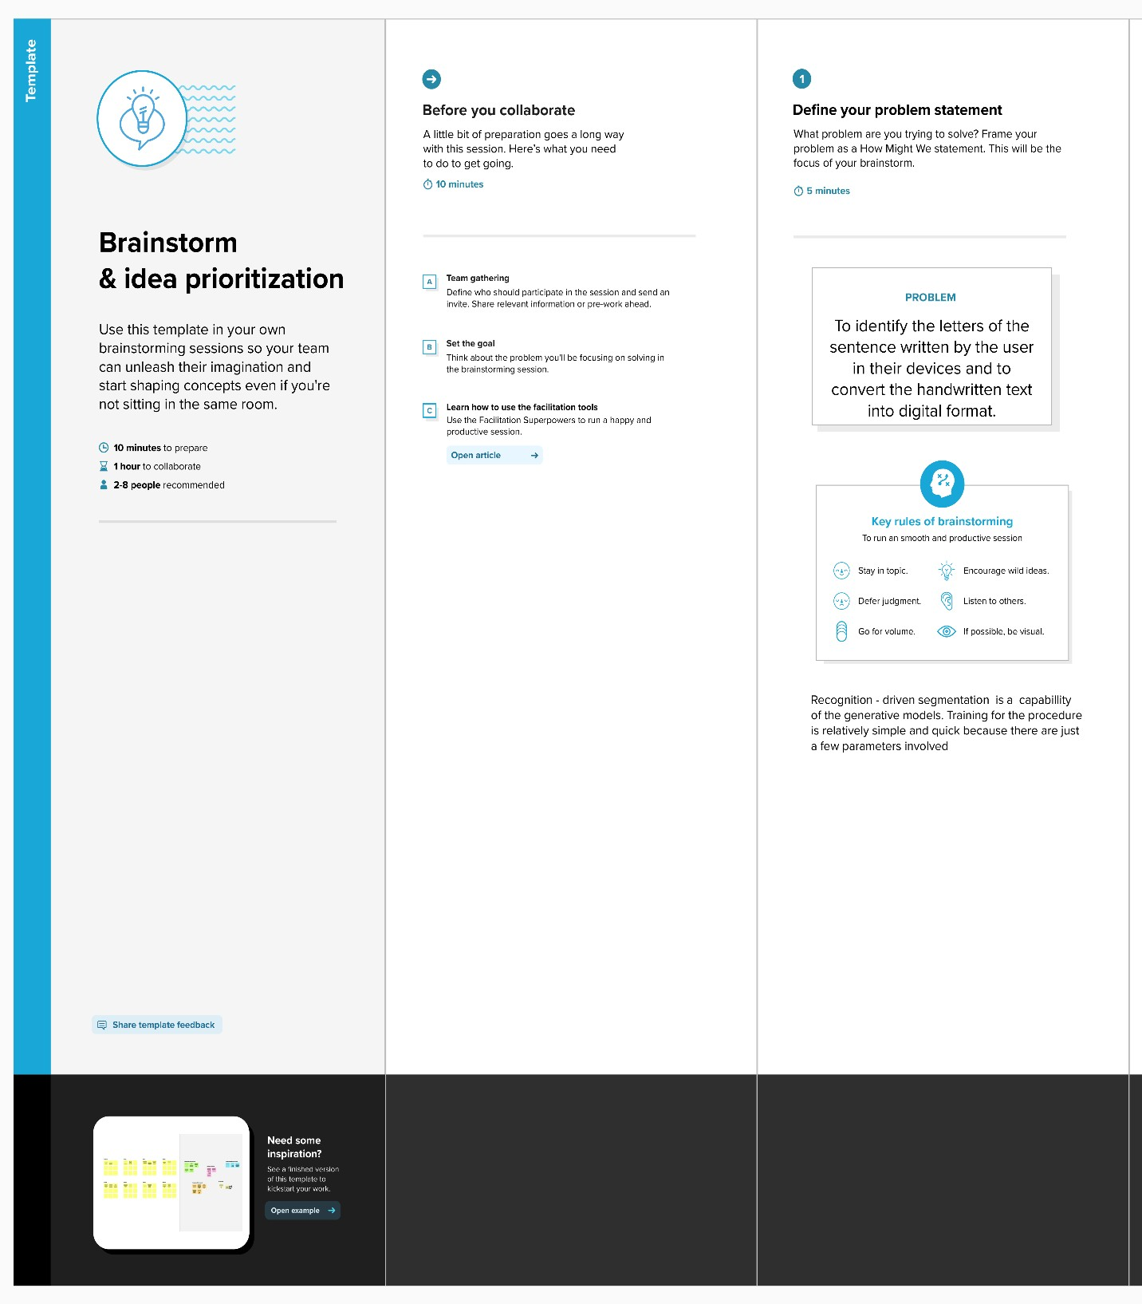

Step-2:

Brainstorm, Idea Listing and Grouping

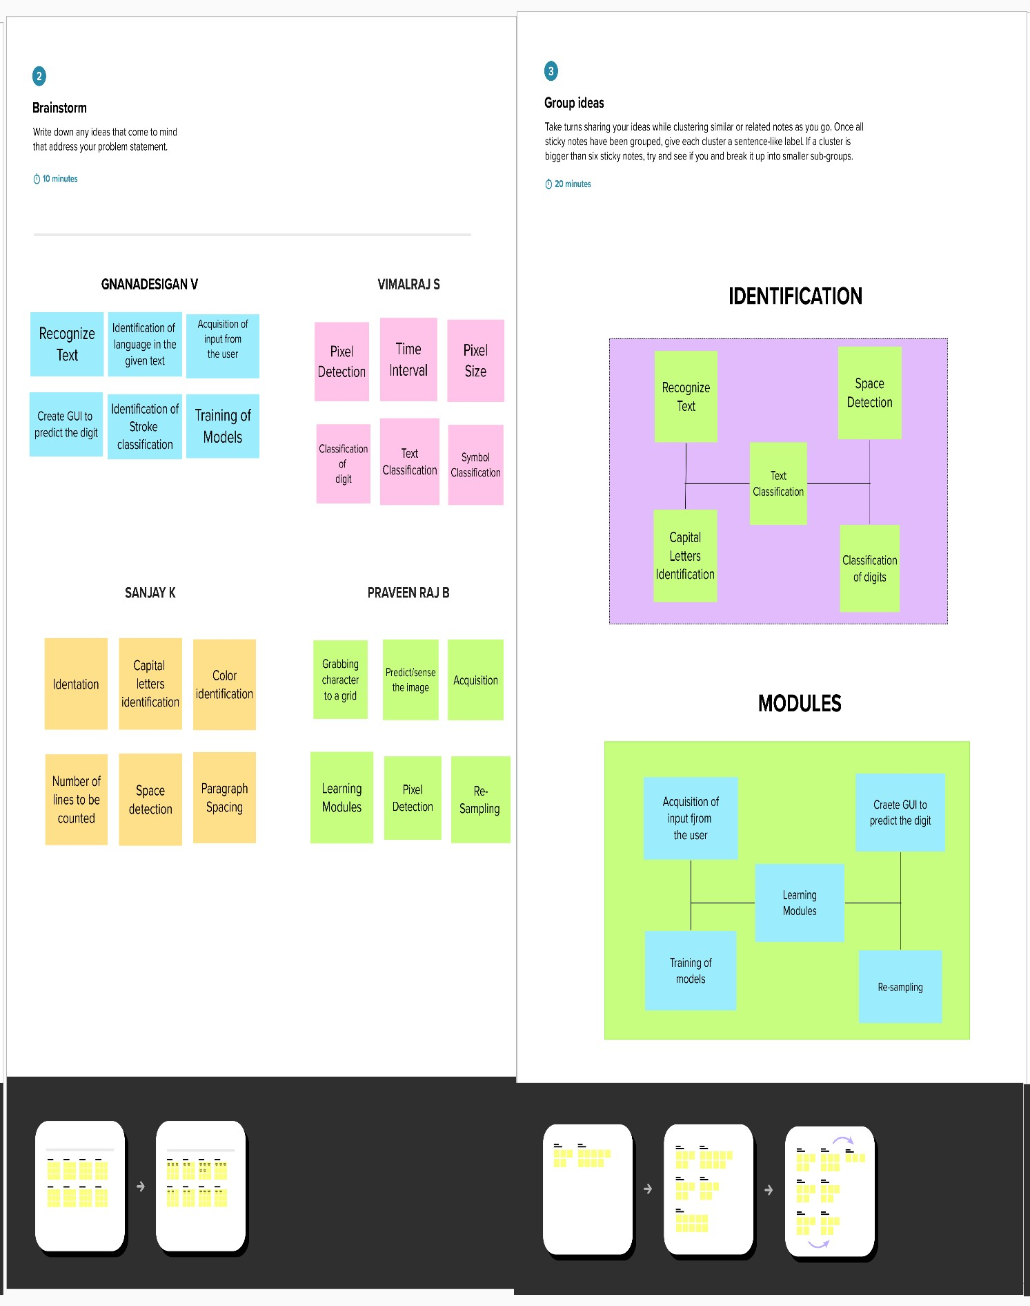

Step-3:

Idea Prioritization

